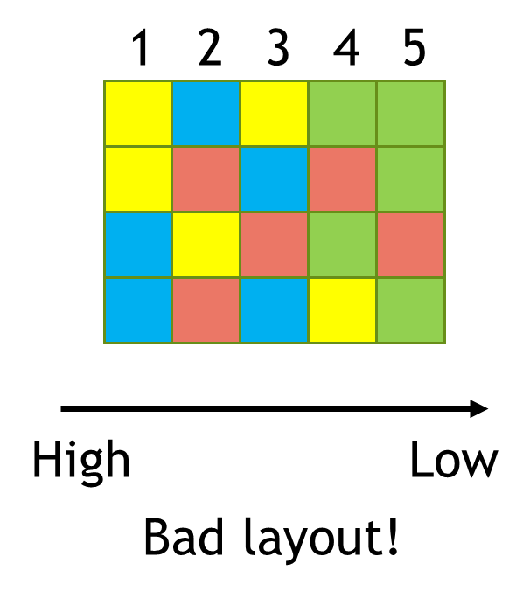

Problem: You are designing a field experiment with 5 treatments and 4 replicates of each. But there’s a gradient at your site that could confound your experiment, so your PI tells you to randomly assign treatments inside blocks along the gradient.

Goal: Design an R function that will create such a block design for you randomly.

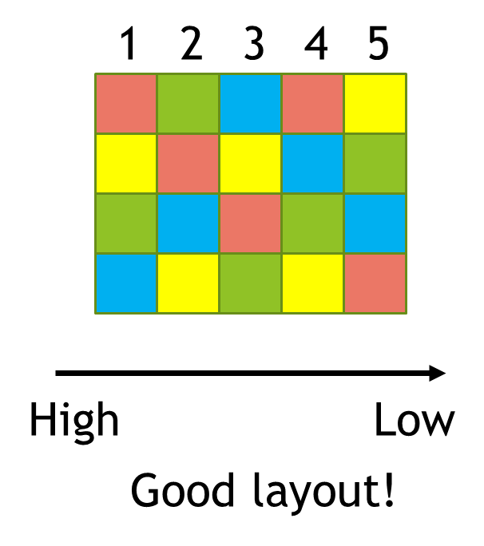

Steps to take:

1. Start with the function skeleton.

2. Set up an empty matrix to store your final layout in.

3. Use a for loop to address one block (i.e. column) at a time.

4. Scramble a set of values that has the same length as the number of treatments (i.e. rows) in each block. If you have four treatments, for example, we would suggest LETTERS[1:4] as a set of values.

5. Make sure to put your scrambled set of treatments into the appropriate column of your matrix using indexing.

6. Use return(“name of matrix”) to have your final layout matrix be the output of your function.